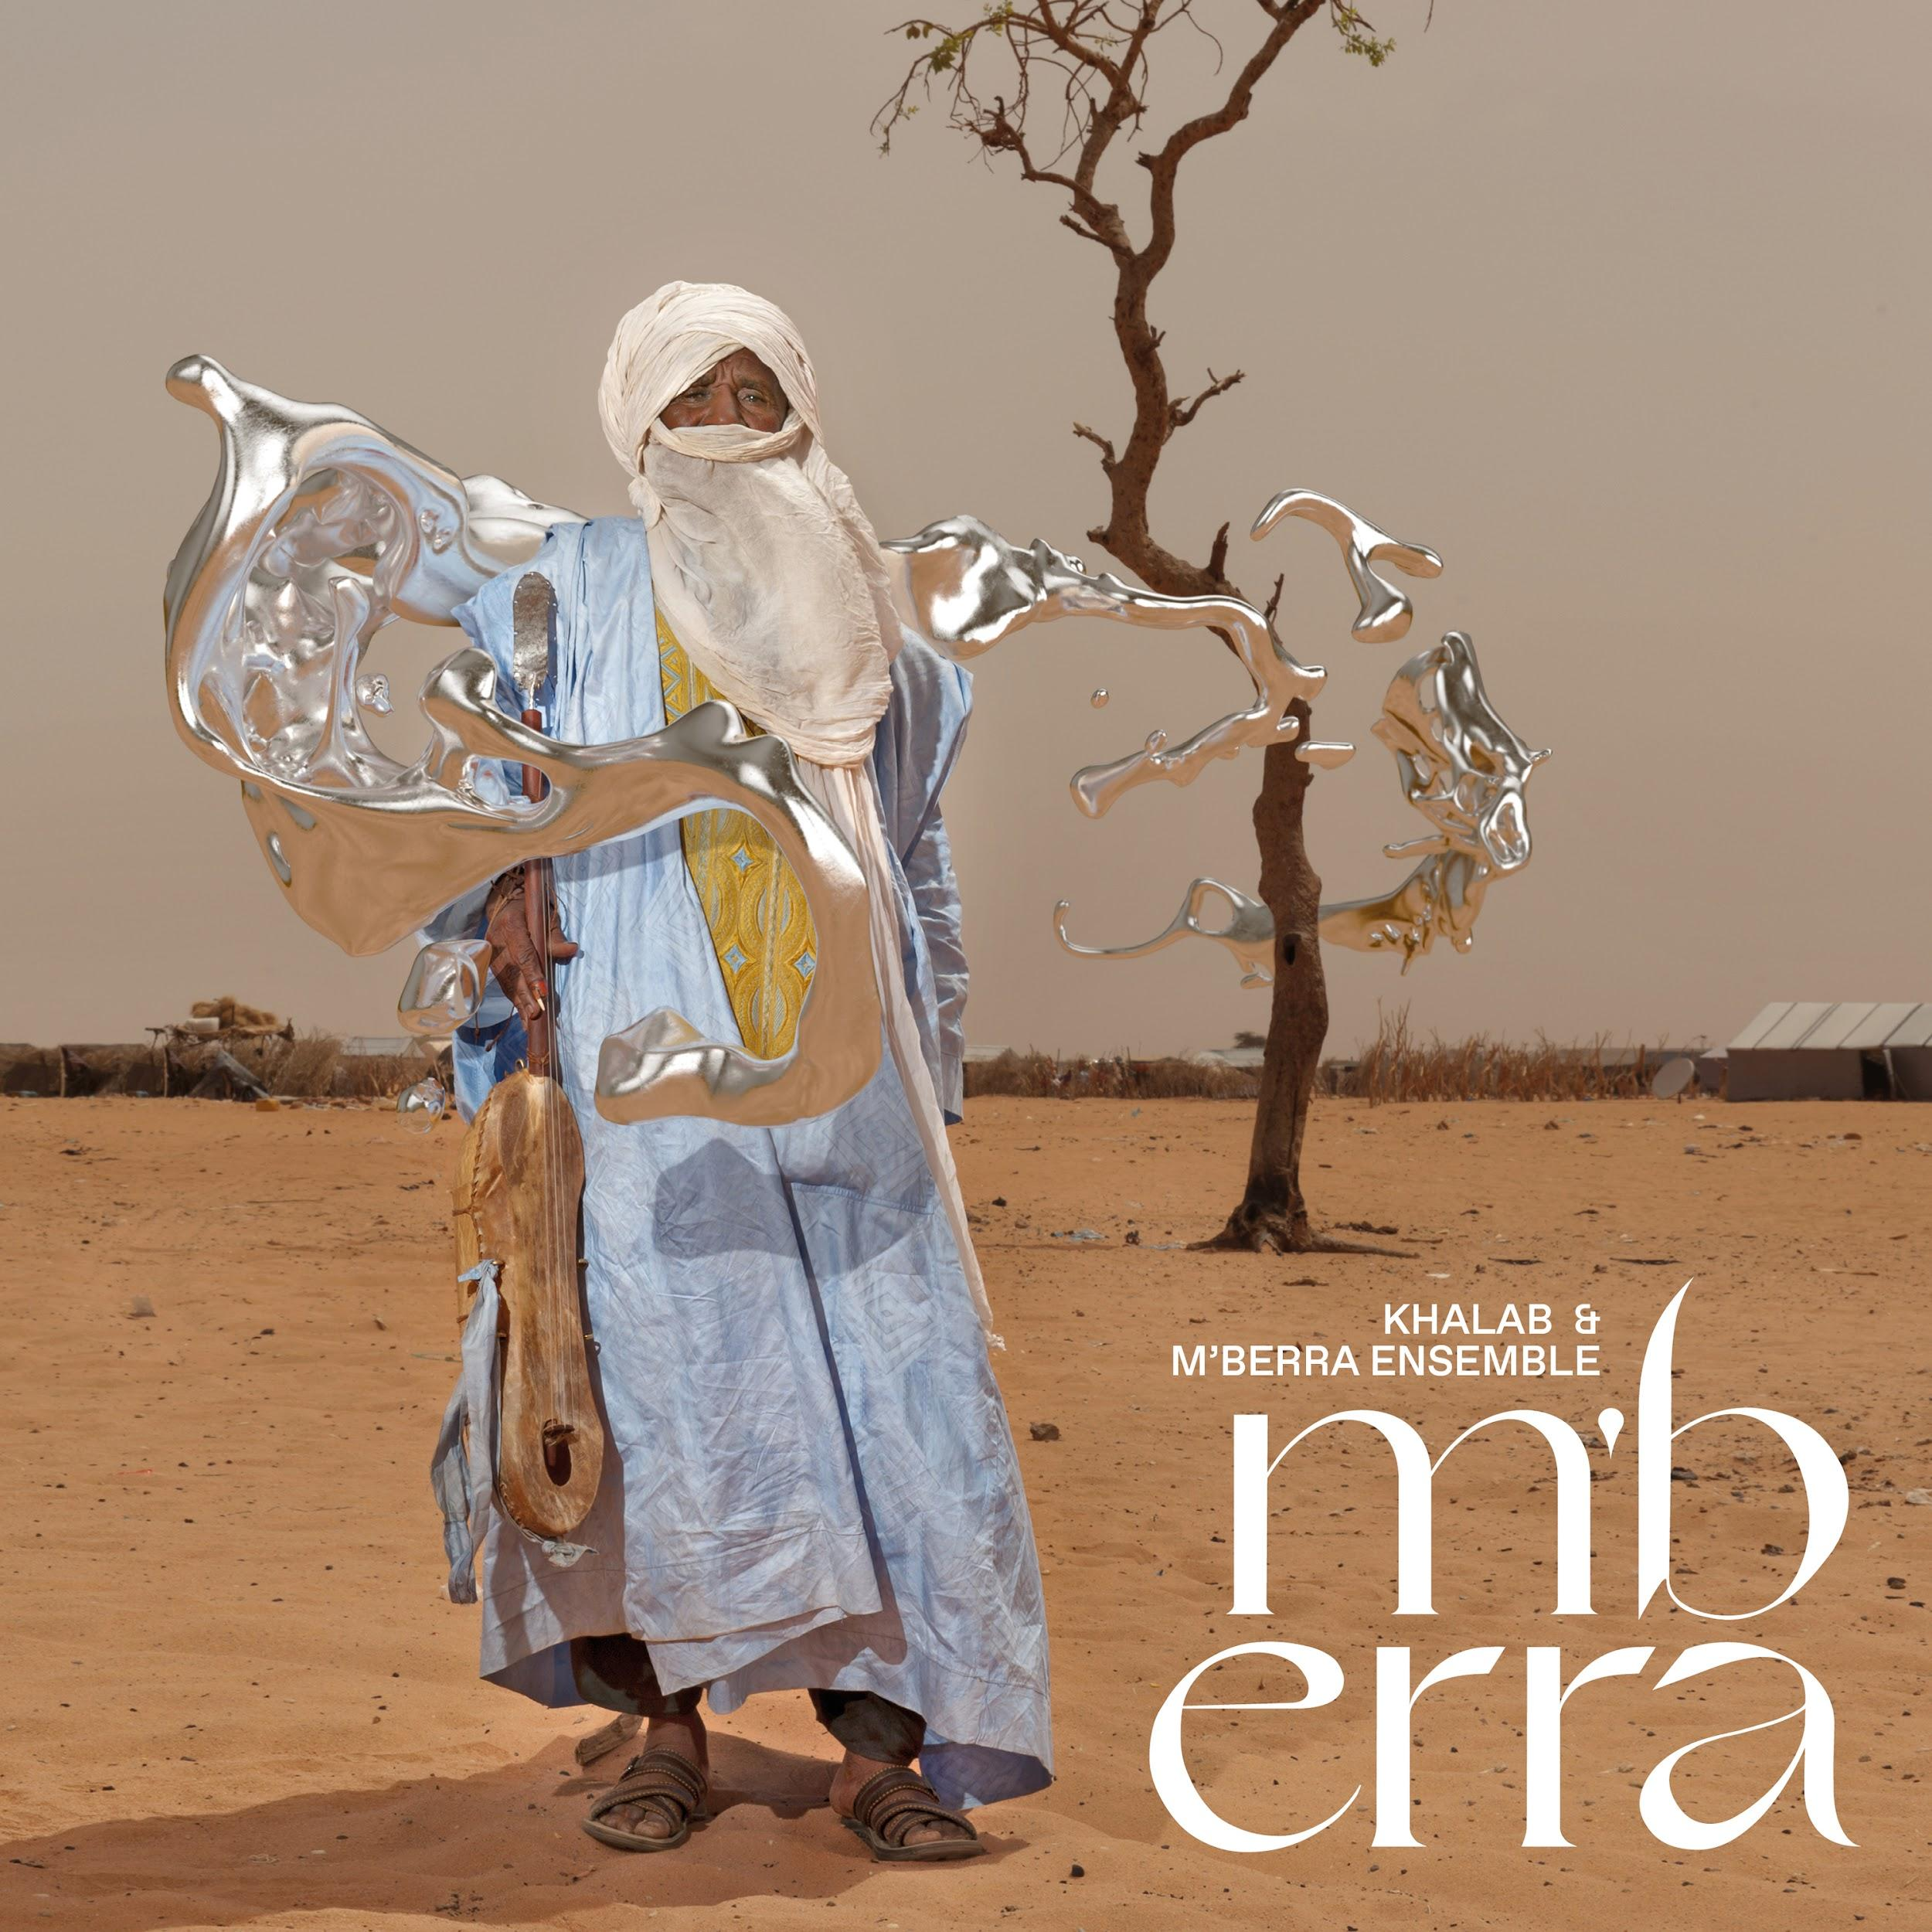

Khalab & M’berra Ensemble
New album: M’berra
Release date: April 23, 2021
Announcement: March 3, 2021

There are stories here. There are memories and dreams, keepsakes and wishes. There are truths told straight and fashioned into shapes. There is struggle and resilience. There is humanity. Throughout, there is music.

Music as connection, sustenance, hope, joy. Ancient-to-future music fed by the ancestors and sent spinning through space and time. Music that bestows agency on the displaced and traumatised, opening the door of the cosmos and embracing the self-determination, the liberation, on the other side.

M’berra. A visionary trip by an artist searching for a new language of storytelling.

This is the sound, the story, of the M’berra Ensemble, a collective of Malian musicians from the M’berra Refugee Camp in southeast Mauritania, and Italian producer and electro-shaman Khalab. In a sprawling tent city rising out of the desert, out of nothingness, at the border with Mali in West Africa, brought together by spirit and circumstance, the group’s Arab and Tuareg members — some unknown, some who have previously toured Europe — find solace and beauty in music and song.

Their truths are authentic, and diverse: “There is not only one story to be told here,” says Khalab, who with French photographer Jean-Marc Caimi visited the camp in 2017 at the invitation of Intersos, the largest Italian NGO on the frontline of global emergencies.

“The real stories feature musicians, their music, their names.” Among them, Amano Ag Issa and Mohammed Issa Ag Oumar of Tartit, that much-feted group from the Tombouctou region of northern Mali. Variously recalling their past and reclaiming their present with proud, gritty vocals; wielding electric guitars and traditional instruments — the lute-like tehardent, the single-string imzad — across 12 tracks that tell of resistance and freedom, of desert storms and desert moons.

M’berra. It’s a docu-fiction, informed by rolling sub-Saharan blues and the space-is-the-place magic of Afro-futurism — a genre and philosophy at the intersection of African diaspora culture and technology, whose early iconic figure Sun Ra famously used extraterrestriality as a trope to explore, subvert and empower.

This is the sound, the story, of Khalab [Raffaele Costantino], a producer with a psychedelic perspective and deep love of African music and indeed, Afro-futurism. Already acclaimed for an oeuvre saturated with loops, repetitions, trance and transcendence, for collaborations with the likes of Malian percussionist Baba Sissoko, Khalab is even more lauded today.

His pivotal 2018 album Black Noise 2084 (On the Corner) and subsequent series of mixes and features from artists including celebrated black British reedsman Shabaka Hutchings have made Khalab a name to drop.

Back in 2017, intent on combating compassion fatigue, wanting to re-sensitise the world to the lives lived inside refugee camps, he landed in the 50,000-strong M’berra Camp. In 48°C (119°F) heat, he prepared the ensemble for take-off.

“Khalab’s electronic music seems so distant, so alien!” says Fadimata Walett Oumar (a.k.a. Disco, leader of Tartit). “At the same time, as I listen and listen again, I feel that Khalab’s music is well harmonized with our voices, our songs, our instruments. I am strongly convinced of the power of innovation of the individual. The mixing of musical genres will keep our tradition alive.”

Recording sessions done solo and in groups were merged with other sounds then rocket-boosted by electronics and post-production in Italy with musicians Adriano Viterbini and Tommaso Cappellato. Ethnologist Barbara Fiore led Khalab into a deeper understanding of the Tuareg culture and traditions and helped him stay connected with the musicians from the M’berra camp.

The Malians with their sand-burnt eyes and candy-coloured robes are deftly captured through the lens of Caimi, whose intimate portraits conjure an enchantment made stark by the surreal desert backdrop.

M’berra is stories within stories: of individual lives upended and reconfigured. Of a small but thriving music scene in an ephemeral metropolis. Of a humanitarian organisation that not only aids but enables. Of an Italian producer tasked with creating a project that unites, transports and heals.

Of the essential nature of music.

Words by Jane Cornwell

M’berra is out on Real World Records on 23 April 2021. The vinyl edition of the album will be available in a deluxe gatefold package with yellow LP and a 32-page booklet — an extraordinary visual accompaniment showing photographs of the musicians at the M’berra camp alongside written accounts of the project told from a number of perspectives. The album is also available digitally, and on CD (with accompanying booklet).

Watch the trailer: https://youtu.be/Xxx1Jpoqy78
Official website: www.khalabmberra.com
Pre-order the album: smarturl.it/RW236

Editor Notes

INTERSOS - www.intersos.org
The M’berra project was made possible through the support of Intersos. Intersos is an Italian humanitarian aid organisation that works all over the world to bring assistance to people in danger, victims of natural disasters, armed conflicts or living in conditions of extreme exclusion.

Khalab
Italian electronic artist and producer Raffaele Constantino a.k.a. Khalab has developed an international reputation for his original fusion of traditional African sounds, deep bass work, jazz, and heavily layered & dense electronic textures. As a passionate researcher and advocate, Khalab has been promoting African music throughout his DJ career on the Italian club and festival scene, as a broadcaster on national Italian network Rai Radio 2, and as a music consultant, author, and event organiser. He has collaborated with the likes of Malian percussionist Baba Sissoko, and emerging icons of the new jazz scene such as Shabaka Hutchings and Moses Boyd. Most recently he experimented with field recordings from the archives of the Royal Museum for Central Africa of Bruxelles on his 2018 album Black Noise 2084. His wide-reaching musical tastes can be heard regularly on his monthly Worldwide FM show, Love from Rome, on which he takes a round trip journey between ancestral rituals and psych, deserts and spaceships.

M’berra Ensemble
‘M’berra Ensemble’ refers to a community of musicians living in the M’berra refugee camp — some who perform as individuals, others who are a part of other bands. They took part in this musical collaboration as a way of restoring their dignity and identity as musicians, and to support and raise awareness for INTERSOS humanitarian projects in the Sahel region of West Africa.

Credits

M’berra Ensemble are: Amano Ag Issa, Mohamed Issa Ag Oumar, Ahmadou Ag Mohamed, Tinalbaraka Walet Alhassane, Alhassane Ag Abdorahmane, Taya Walet Mohamed, Aliou Ould Mohamed, Attaher Ag Mohamed, Attaye Ag Mohamed, Elhaj Ag Mohamed, Enaderfé Ag Khamma, Hamma Ag Awaissoune, Mohamed Alwafi Ag Mohamed, Khantara Ould Mohamed, Adriano Viterbini, Tommaso Cappellato, Davide Paulis, and DJ Knuf.
All tracks written by Khalab & M’berra Ensemble
Recorded in the Mauritanian desert in May 2017
Produced & arranged by Khalab
Mastered by BitBazar
Mixed by DJ Knuf & Khalab at Studio 33, Rome between September 2019 & September 2020
Photos by Jean-Marc Caimi
Graphic project by Mine Studio
Graphic 3D work by Aira
Published by Real World Works Ltd

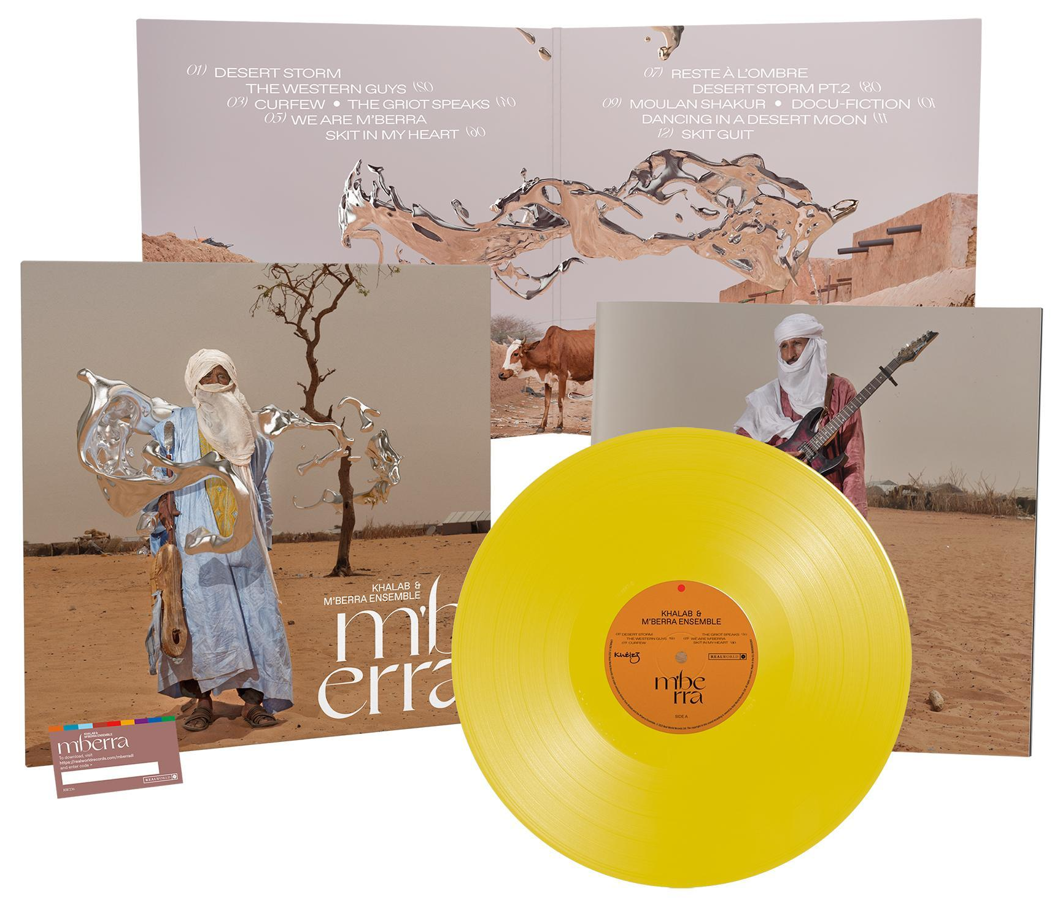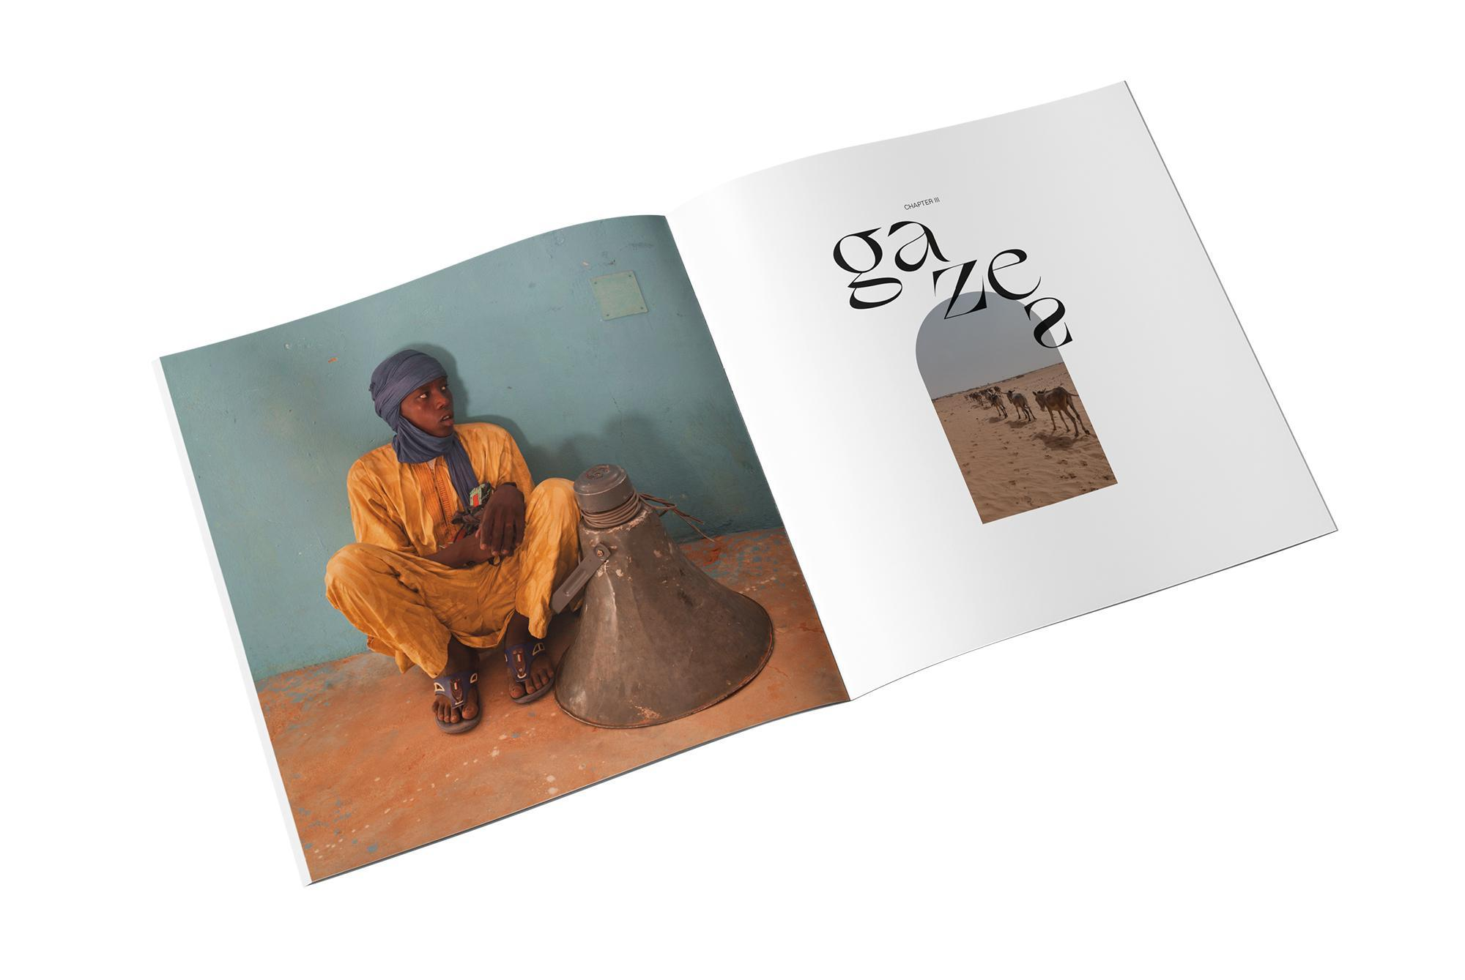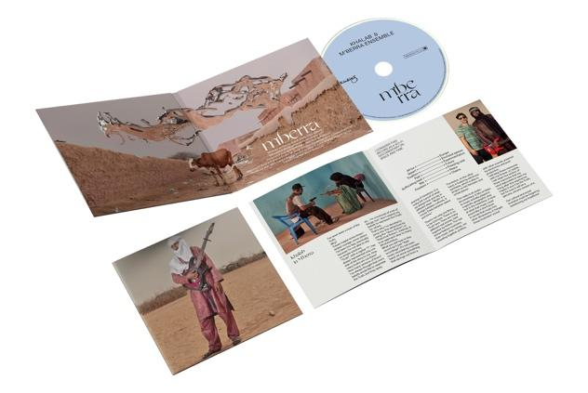

Gatefold coloured vinyl with 32-page 12” booklet

